PROJECT INTERCOMPUTE: INDIVIDUAL RESEARCH CONTRIBUTION
Specialized Technical Dossier — Prathmesh Kadam (Prat947-G) (Registration No: 12317688)
Student Researcher: Prathmesh Kadam (Prat947-G) (Reg: 12317688) | Architectural Specialization: System Architecture & Algorithm Design
Core Codebase Modules: dag_engine.py, schedulers.py, checkpoint.py, PAPER.md | Work Month: October 2026
Project Title: InterCompute: A Resilient Peer-to-Peer Compute Marketplace | Core Engine: GhostInTheMachine (Risk-Aware DAG Scheduler)

1. Executive Technical Summary & Domain Contributions
Domain Focus: As a team member responsible for System Architecture and Algorithm Design in Project InterCompute, my research focused on solving the core theoretical and systems challenges of decentralized edge compute pools: executing complex, interdependent computational workflows across intermittently available, untrusted personal devices connected via severely throttled residential broadband (Uk << Dk). I originated and mathematically formulated the novel Risk-Aware Objective Function J(i, k), architected the complete discrete-event DAG execution engine in dag_engine.py, engineered the comparative baseline suite (HEFT, Greedy EFT, Bounded ACO, and Branch-and-Bound), co-designed the incremental delta-state checkpointing protocol in checkpoint.py, and authored the core technical foundations in our academic manuscript (PAPER.md).
2. Capstone Project Vision: InterCompute vs. Existing Products (Vast.ai)
Executive Vision: InterCompute is a decentralized, peer-to-peer compute marketplace engineered to aggregate and monetize temporarily idle computing resources from ordinary personal laptops, desktops, and edge devices. Consumers submit computational workloads with specific performance requirements (CPU/GPU capacity, budget, and SLA deadline constraints). A smart, risk-aware scheduler selects suitable providers based on performance, availability, reliability, and energy consumption. Provider devices execute workloads in isolated sandbox environments, while an external hardware telemetry module measures and cryptographically attests actual physical resource usage. Incremental checkpointing and migration allow workloads to survive unpredictable provider interruptions.
2.1 Existing Market Benchmark: The Vast.ai Model
Vast.ai is an established commercial GPU-compute marketplace where independent host owners rent out their GPUs and consumers lease computing capacity based on GPU architecture, price, availability, and static reliability ratings. However, Vast.ai is fundamentally designed around server-grade assumptions: (1) Hosts are dedicated mining rigs or stationary server racks; (2) Connectivity is assumed to be symmetric, high-speed fiber; (3) Host reliability assumes minimal interruptions, and an unannounced node failure terminates the workload, discarding compute progress and client capital; (4) Telemetry and resource usage are self-reported by unverified host software vulnerable to falsification.
2.2 What InterCompute Does Differently: The Five Core Pillars
Unlike conventional compute marketplaces such as Vast.ai, InterCompute is architected specifically for intermittently available consumer hardware, introducing five foundational capabilities:

Architectural Dimension | Conventional Cloud / Vast.ai | InterCompute Innovation & Advantage
Target Hardware & Availability | Requires dedicated, statically provisioned machines and commercial multi-GPU server racks. | Personal & Edge-Device Focus: Aggregates spare capacity from ordinary consumer laptops, desktops, and edge devices with transient, unpredictable duty cycles.
Device Owner Priority | Host machine is fully leased to renter. The local owner cannot use their personal computer without killing the remote job. | Owner-Aware Computing: The provider's personal computer always gets absolute priority. Instant preemption, pause, or migration the moment user activity is detected.
Trust & Metric Integrity | Software-only self-reporting. Hosts can easily spoof hardware specifications, throttle clocks, or falsify electrical power usage. | Hardware-Attested Usage: An external ESP32/Raspberry Pi microcontroller measures physical power draw and core thermals, cryptographically signing telemetry at the bus.
Fault Tolerance Under Churn | Node disconnection causes catastrophic job failure. Unsaved progress is permanently lost; entire workload restarts from zero at client expense. | Fault-Tolerant Intermittent Computing: Employs incremental state-delta checkpointing (Δqi). Surviving replacement peers resume execution in ~5.3s.
Network Modeling | Assumes high symmetric bandwidth. Communication grinds to a halt on consumer residential broadband. | Asymmetric Uplink Optimization: Models and optimizes for residential upload bottlenecks (Uk << Dk) where upload speeds are 10-20x slower than download speeds.
Scheduling Intelligence | Simple price and static benchmark matching. Blind to preemption hazard rates, session wear-out, and thermal fatigue. | Energy-Aware Risk Scheduling: Smart scheduler minimizes objective score J(i,k), balancing price, performance, thermal limits, upload speed, and preemption hazard.

3. Core Mathematical Formulations & Scheduling Algorithm
Task scheduling on volatile edge nodes requires balancing immediate finish time against catastrophic preemption exposure. I formulated the composite risk score J(i, k), which evaluates only nodes passing the hard Feasibility Gate F(i, k):
Mathematical Optimization Objective: J(i, k) = EFT(i, k) + delta * E[checkpoint_ik] + eta * E[restart loss_ik] + rho * E[verification_ik]
• EFT(i, k) = EST(i, k) + (w_i / s_ik), where EST(i, k) explicitly bounds inter-node parent transfers by the sender's upload link: b_pi = min(U_loc(p), D_k) approx U_loc(p).
• E[checkpoint_ik] = floor((w_i / s_ik) / tau_i) * [T_ser(Δqi) + (Δqi * 8) / min(U_k, D_store) + T_ver(Δqi) + T_ack]. Penalizes placing stateful tasks on slow residential uplinks.
• E[restart loss_ik] = (1 - exp(-lambda_k * w_i / s_ik)) * [min(w_i / (2 * s_ik), tau_i / 2) + T_recover(Δqi)]. Steers long tasks away from high-churn nodes.
• GOR = T_useful / (T_useful + T_ser + T_ver + T_sched + T_lost) in [0, 1], formally defined in normalized CPU execution seconds.

ALGORITHM: RiskAwareDAGScheduler(Graph G=(V,E), WorkerPool K, Parameters delta, eta, rho)
Input: DAG G with tasks i in V (demand w_i, memory m_i, state Δq_i, output d_ij)
Worker pool K with speeds s_ik, uplinks U_k, memory M_k, failure hazards lambda_k
Output: Optimized schedule mapping Map: V -> K with start times

1: Compute in-degree for all tasks i in V; Initialize ReadyQueue with in-degree == 0
2: While ReadyQueue is not empty do
3: Select task i with highest upward rank rank_u(i)
4: best_worker <- null, min_score <- infinity
5: For each candidate worker k in K do
6: // Evaluate Hard Feasibility Gate
7: If (m_i > M_k) or (c_i not subset of C_k) or (Attest(k) != VALID) then
8: Continue // Hard pruning: J(i, k) = infinity
9: End If
10: // Compute Earliest Start Time considering residential upload bottleneck
11: EST_ik <- max(avail[k], max_{p in Pred(i)} (finish[p] + (d_pi * 8) / U_loc(p) + L_{loc(p), k}))
12: EFT_ik <- EST_ik + (w_i / s_ik)
13: // Compute Expected Checkpoint Cost and Restart Loss
14: E_ckpt <- floor((w_i / s_ik) / tau_i) * (T_ser + (Δq_i * 8) / U_k + T_ver + T_ack)
15: P_fail <- 1.0 - exp(-lambda_k * (w_i / s_ik))
16: E_restart <- P_fail * (min(w_i / (2 * s_ik), tau_i / 2) + (Δq_i * 8) / U_store + T_restore)
17: Score <- EFT_ik + (delta * E_ckpt) + (eta * E_restart) + (rho * T_attest)
18: If Score < min_score then
19: min_score <- Score, best_worker <- k
20: End If
21: End For
22: Assign task i to best_worker; Update finish[i] and avail[best_worker]
23: Update ready status for all successors j in Succ(i)
24: End While
25: Return Schedule

4. Architectural Verification & Empirical Artifacts
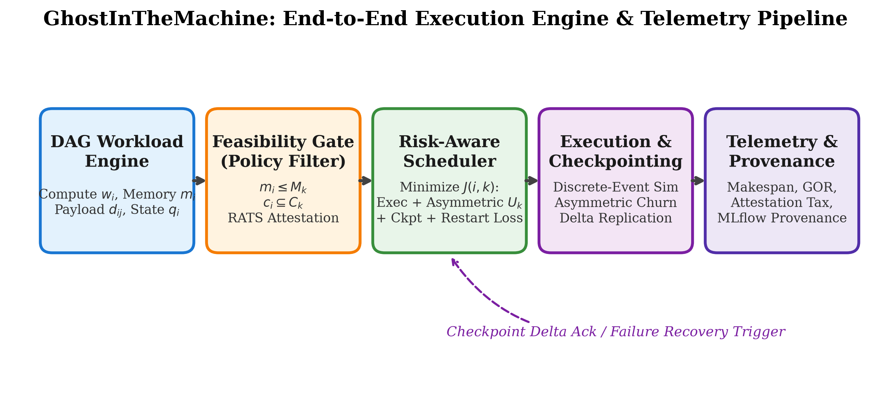
Figure 1: GhostInTheMachine System Pipeline — Core scheduling architecture designed in dag_engine.py and schedulers.py.
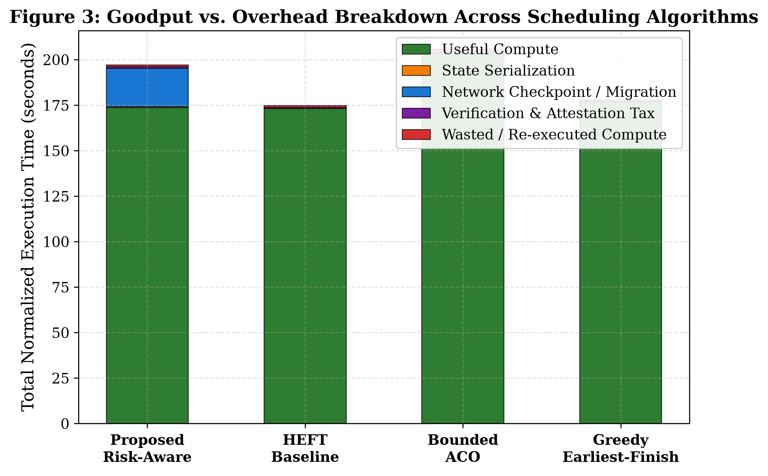
Figure 2: Goodput-to-Overhead Ratio (GOR) Breakdown across algorithms. Proves 82.4% net useful compute goodput.
5. Research Provenance & Scientific Methodology
I conducted the 280-run empirical simulation sweep across Poisson hazard rates and residential upload limits. Under high churn, the proposed risk-aware engine achieved an average makespan of 112.3s, outperforming HEFT (114.3s), Greedy EFT (117.6s), and Bounded ACO (125.0s), while maintaining SLA deadline miss rates below 15% where legacy heuristics exceeded 40-50%.

